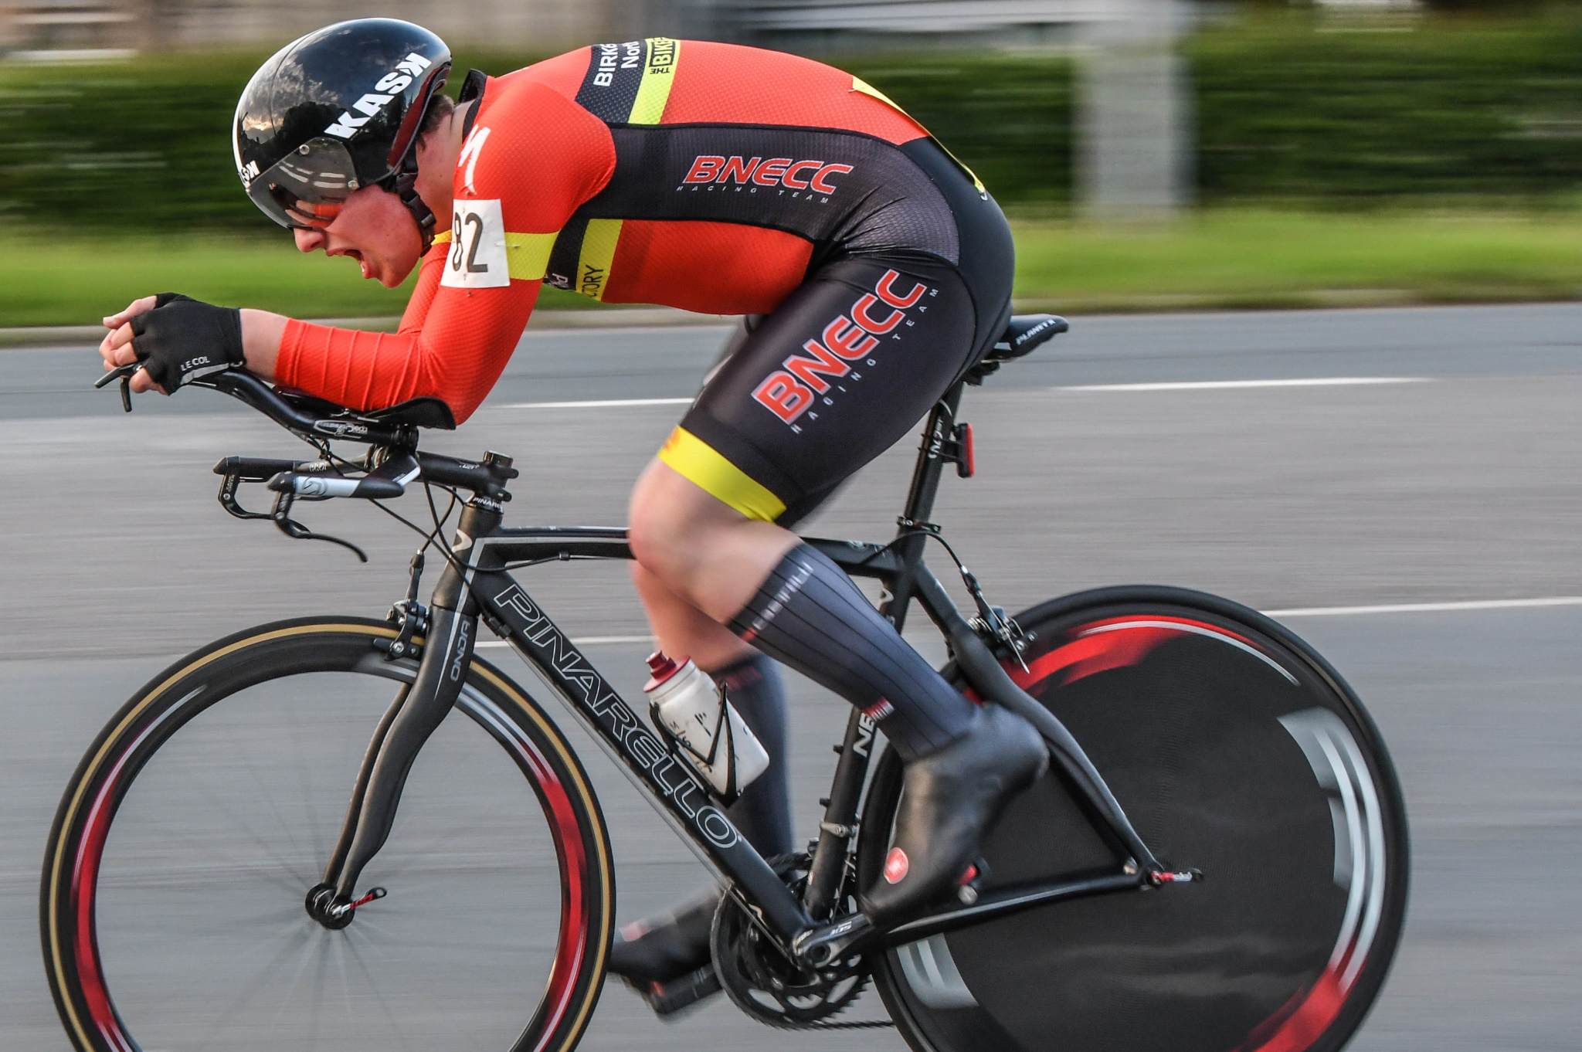
Birkenhead North End
Jack McAllister Memorial
Open 25 Mile Time Trial
Sunday 25th June 2023

Promoted for and on behalf of Cycling Time Trials under their Rules & Regulations
Course:D25/8E Start Time:07:00 Timekeepers: Dave Large & John Lahiff
Event secretary:John Owens 20 New Lincoln Rd Ellesmere Port CH65 4DL
Tel: 07894 308571 email: john_owens137@outlook.com
Headquarters:Tilstock Village Hall, Tilstock, SY13 3JL, 2.5 miles S of Whitchurch, open from 6:00am
Additional parking is available on the hard standing at Prees HeathSY13 3JT,
just 0.9 miles from the HQ and adjoining the course.

Competitor’s Notes: Each competitor must sign on when collecting AND RETURNING their race numbers at the HQ, this is a CTT Requirement. Numbers should be pinned to the lower back area and be clearly visible. Make sure you call out your number at the finish, otherwise your time may not be recorded. Times will be displayed at HQ, do not ask for your time at the finish.
Distance from HQ to start is 3.8 miles so allow adequate time. Please use extreme caution riding on the A49, you are on the course so please ride in single file. The road narrows at Sandford Bridge on the A41. There is also a possibility of cattle crossing just north of the bridge. Any rider performing a U-turn within sight of the start or finish may be disqualified. Please follow the 'Route to start' outlined below. Keep your head up at all times, have a safe and enjoyable ride.
ALL Riders MUST have a working Front AND Rear Light fitted to their machine as set out in CTT Reg 14(i) & 14(j). Riders with no working front & rear light will not be permitted to start. ALL Riders MUST wear a helmet as set out in CTT Reg 15. Riders without a helmet will not be permitted to start. Riders must negotiate Prees Heath and Tern Hill Roundabouts (RABs) in a safe and sensible manner in accordance with CTT Reg. 20 and the rules of the road. Riders must be able to brake and stop at the island if traffic conditions require this. Riders MUST NOT USE their tri-bars / extensions from a point 25 metres before entering the RAB and for 10 metres after leaving it. Any rider seen to be in breach of this regulation will be disqualified from the event and may be reported for further disciplinary action.
AWARDS
 | Fastest rider |  | Fastest Lady | Fastest junior | Fastest vet | Fastest Road Bike Male/Fem | Vet +on Std
1st | £30 |  | £30 | £20 | £20 | £20 | £25
2nd | £20 |  | £20 | £15 | £15 |  | £20
3rd | £15 |  | £15 |  |  |  | £15
Fastest Team of 3 |  | £30

Please note –the One Rider One Prize rule applies, except for Team prize.

Course Description
Start on the A49 (Prees bypass) south of Prees Bridge at metal bridge join.
Proceed north on the A49 to Prees Island 2.76miles
Turn right onto the A41 (3rd exit) and continue to Tern Hill Island 9.79
Turn right onto the A53 (3rdexit) and proceed to Espley Island 13.13
Encircle island and retrace to Tern Hill island 16.50
Turn left (1stexit) onto A41 and retrace to Prees Island 23.47
Turn left (1st exit) onto A49 and Finish at last grid before Manor House Lane 25.00

Route Maps
Route To Start
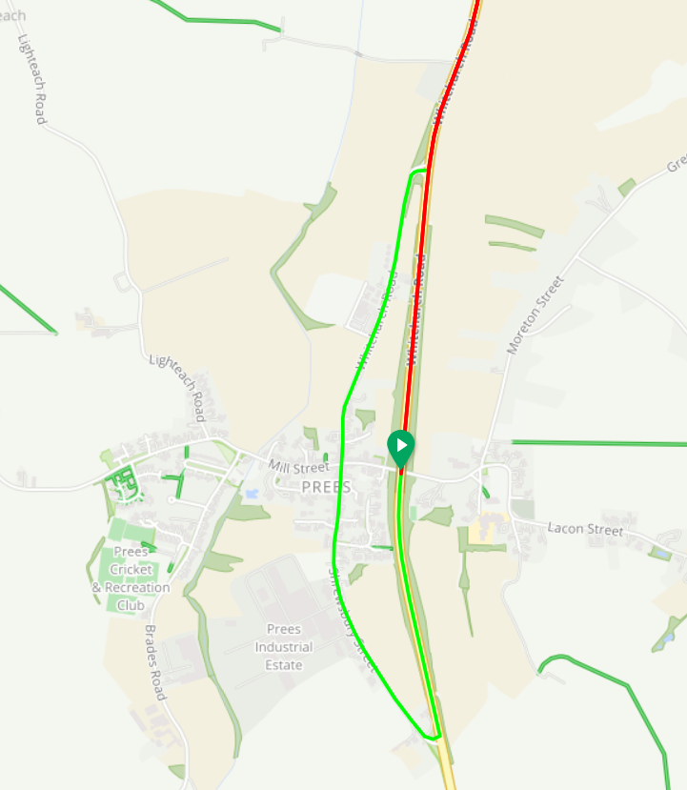
Course
